**Experiment No. 5 - KHUSHBOO JAIN (G7 – 2410993045)**

**Aim:** To evaluate time-of-flight principles through HC-SR04 ultrasonic transceiver

operation, calculating object proximity via pulse-echo timing measurements.

**Apparatus**: Wokwi Simulator

**Circuit Layout:**

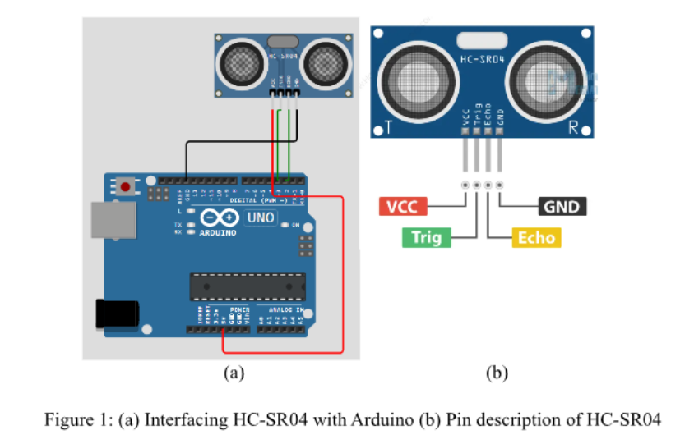

**Theory:**

The HC-SR04 Ultrasonic Sensor works on the principle of echo. It sends out an ultrasonic pulse at 40kHz through its transmitter (TRIG pin). When this sound wave hits an object, it reflects back and is received by the receiver (ECHO pin). The time taken for the echo to return is measured, and using the speed of sound in air (approximately 343 m/s), the distance is calculated.

**Pin Description of HC-SR04**

1. VCC → +5V power supply

2. GND → Ground

3. TRIG → Trigger pin to send ultrasonic pulses

4. ECHO → Echo pin to receive reflected signal

**Working Principle**

1. The Arduino sends a HIGH signal to the TRIG pin for 10 microseconds.

2. The sensor emits ultrasonic pulses.

3. When the pulses hit an object, they reflect back.

4. The ECHO pin outputs a pulse whose duration corresponds to the time taken for the echo to return.

5. The Arduino measures this duration and calculates distance using: Distance = (Time × Speed of Sound) / 2

**Circuit Layout**

Connections:

- VCC → 5V

- GND → GND

- TRIG → Pin 3

- ECHO → Pin 2

- LED (with resistor) → Pin 13

The LED will turn ON when an object is detected within 100 cm and turn OFF otherwise.

**Code Used:**

#define ECHO_PIN 2

#define TRIG_PIN 3

void setup() {

Serial.begin(115200);

pinMode(LED_BUILTIN, OUTPUT);

pinMode(TRIG_PIN, OUTPUT);

pinMode(ECHO_PIN, INPUT);

}

float readDistanceCM() {

digitalWrite(TRIG_PIN, LOW);

delayMicroseconds(2);

digitalWrite(TRIG_PIN, HIGH);

delayMicroseconds(10);

digitalWrite(TRIG_PIN, LOW);

int duration = pulseIn(ECHO_PIN, HIGH);

return duration * 0.034 / 2; // convert to cm

}

void loop() {

float distance = readDistanceCM();

bool isNearby = distance < 100; // threshold 100 cm

digitalWrite(LED_BUILTIN, isNearby);

Serial.print("Measured distance: ");

Serial.println(distance);

delay(100);

}

**Simulation Outcome:**

**Result:**

The Serial Monitor continuously displays the measured distance in centimeters. If an object is placed within 100 cm of the sensor, the LED turns ON. Otherwise, the LED remains OFF.

The project successfully demonstrates the use of the HC-SR04 Ultrasonic Sensor with Arduino Uno to measure distance and control an LED as an indicator